Optical motion sensors
The sensors to measure the position of the sphere are two PCB boards based on the Avago Technologies ADNS-3050 [1] optical flow sensor and extracted from the Cougar Minos X2 gaming computer mouse [2]. This sensor has high motion detection under speeds of 152.4 cm/s and can deal with accelerations up to 20g. It has selectable resolutions up to 2000 cpi (we have used the default configuration of 1000 cpi). Also has a register that outputs the SQUAL value, a reference of the quality of the surface. This makes the calibration process more simple.
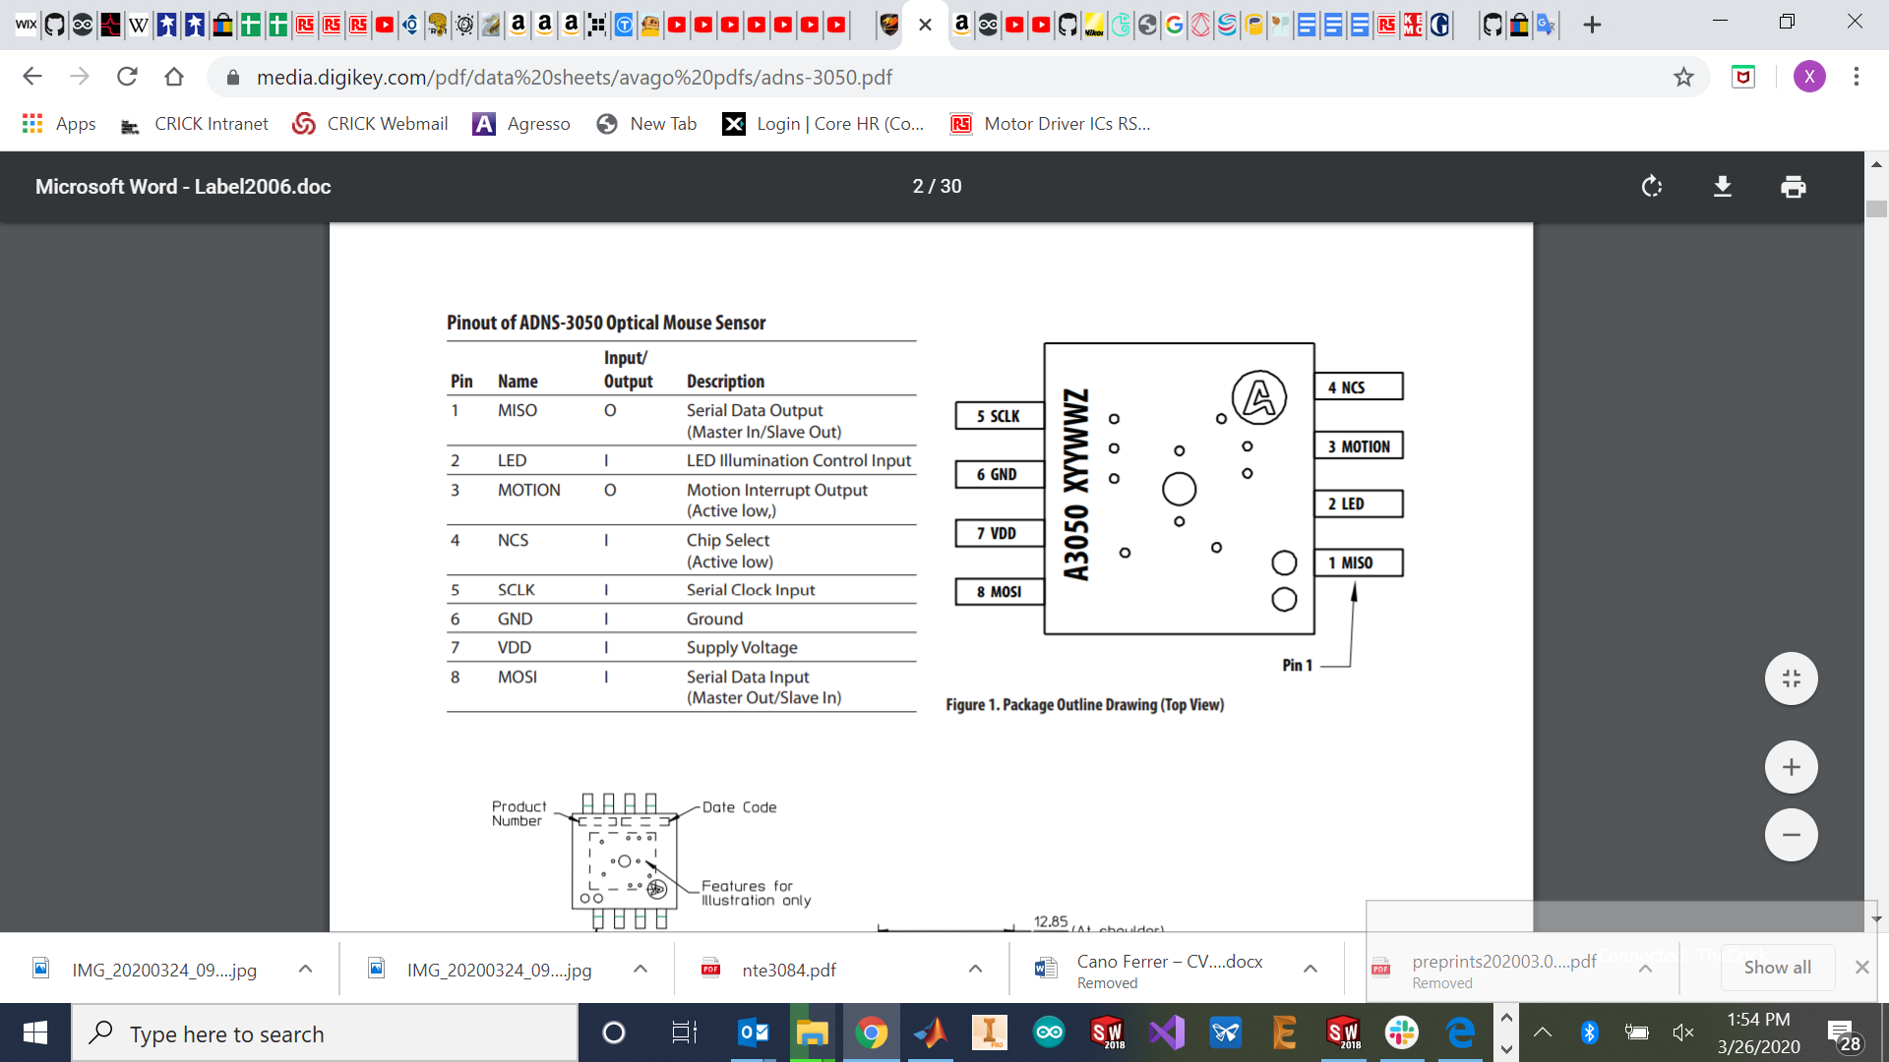
Figure 1: Pinout of the ADNS-3050 [1].
The PCB and the lens are attached to a 3D printable structure which can achieve horizontal and vertical displacements with reliability and resolution of 0.01 mm. The displacements are regulated with two micrometers with a 13 mm range (RS Components 785-7875).
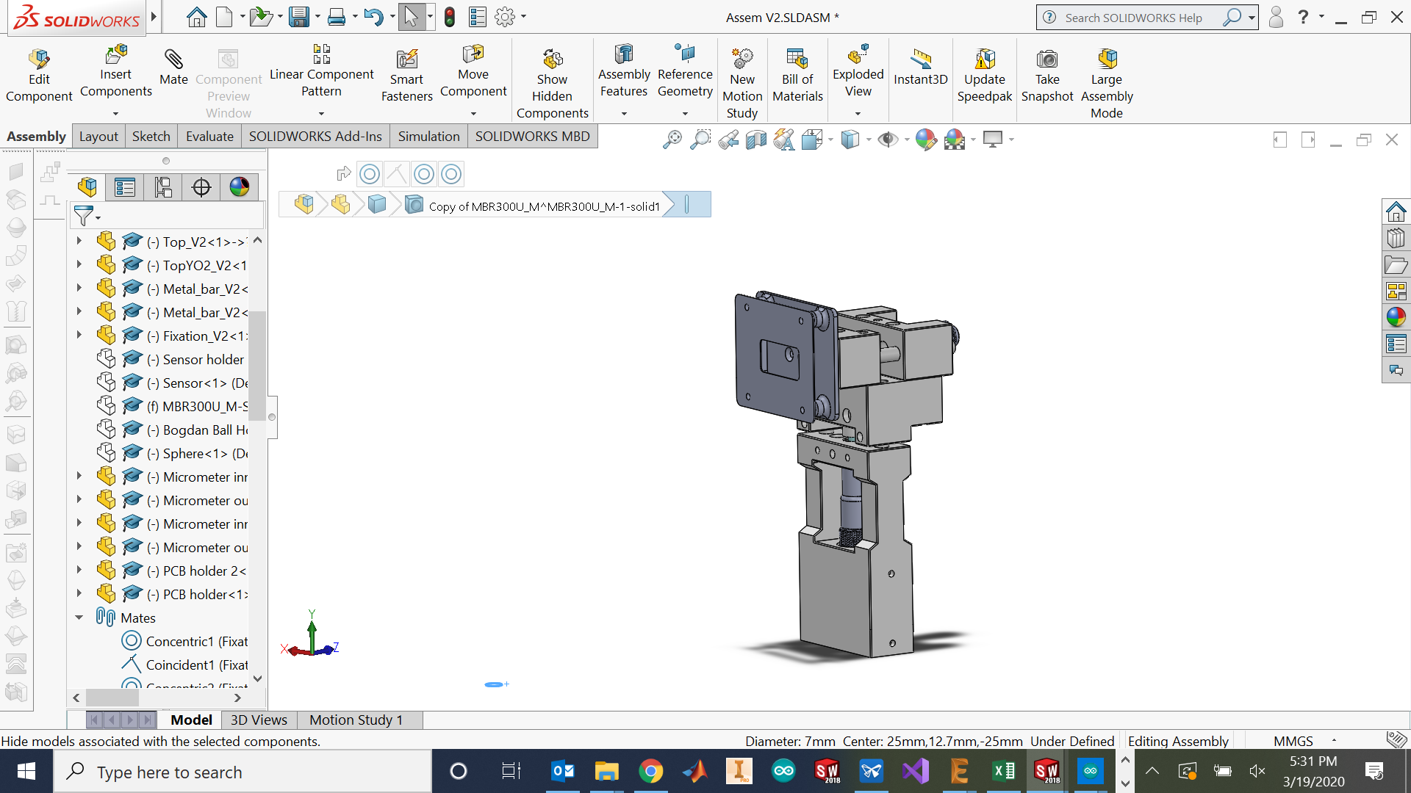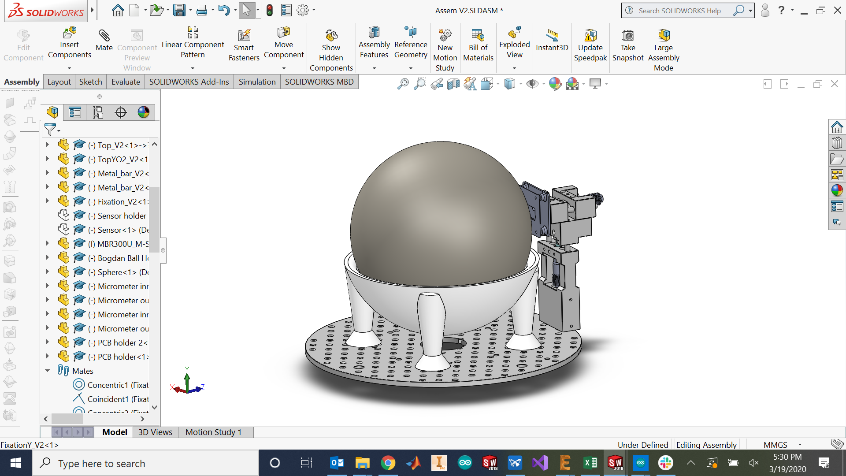
Figure 2: Micrometer structure CAD design.

Assembly instructions
The first step is to acquire all the components needed:
Table 1: Bill of materials (For each sensor).
Component | Quantity | Supplier | Reference
Optical mouse | 1 | - | https://cougargaming.com/products/mice/minos_x2/
Mobile part x | 1 | - | 3D printed part
Mobile part y | 1 | - | 3D printed part
Base part x | 1 | - | 3D printed part
Base part y | 1 | - | 3D printed part
PCB holder | 1 | - | 3D printed part
PCB holder 2 | 1 | - | 3D printed part
M2 x 4 mm | 4 | RS Components | 914-1462 RS PRO Pozidriv Pan Head A2 304 Stainless Steel Machine Screw, M2, 4mm
M3 x 8 mm | 8 | RS Components | 908-7481 RS PRO Pozidriv Countersunk Head Bright Zinc Plated Steel Machine Screw, M3, 8mm
M3 x 4 mm | 2 | RS Components | 556-580 RS PRO, M3 Pan Head, 6mm Steel Pozidriv Bright Zinc Plated
M3 x 12 mm | 2 | RS Components | - 528-952 RS PRO, M3 Countersunk Head, 12mm Stainless Steel Pozidriv A2 30
M3 x 20 mm | 12 | RS Components | 560-625 RS PRO Pozidriv Pan Head Bright Zinc Plated Steel Machine Screw, M3, 20mm
M3 x 6 mm | 4 | RS Components | 137-720 RS PRO M3 x 6mm Hex Socket Set Screw Plain Stainless Steel
M4 x 6 mm allen prisoner screw | 2 | RS Components | 529-949 Black, Self-Colour Steel Hex Socket Set M4 x 6mm Grub Screw
Connectivity Male UNC 4-40 Screw Lock for use with D-sub Connector | 4 | RS Components | 717-4505 TE Connectivity Male UNC 4-40 Screw Lock for use with D-sub Connector
Micrometer | 2 | RS Components | 785-7875 Midi Micrometer Head 0-13mm
Metal cilinder 6 mm | 4 | Thorlabs | ER2-P4 - Cage Assembly Rod, 2" Long, Ø6 mm, 4 Pack
Extension spring | 4 | Ebay | TENSION SPRING - 0.5mm WIRE - 20mm (L) x 5mm (OD) - ES017
M6 threaded insert | 1 | RS Components | 664-7359 Böllhoff Galvanised, M6 Steel Threaded Insert Depth 14mm
M3 threaded insert | 4 | RS Components | 278-534 RS PRO, M3 Brass Threaded Insert diameter 4mm Depth 4.78mm

In order to use the mice sensors, the PCB and the lense must be removed from the optical mouse and the VDD, GND, MISO, MOSI, NCS and SCLK must be soldered with wires to be connected to the microcontroller with the microcontroller 3.3V power supply output. These pins are the pins for SPI communication, the SCLK is the clock selected on the ADNS-3050.h C++ library in our case the Arduino DUE internal clock divided by 21 (4 MHz). The NCS is the pin which allows communication with more than one device by changing the state of this pin to HIGH or LOW. The MOSI and MISO pins are to send the data in both directions.
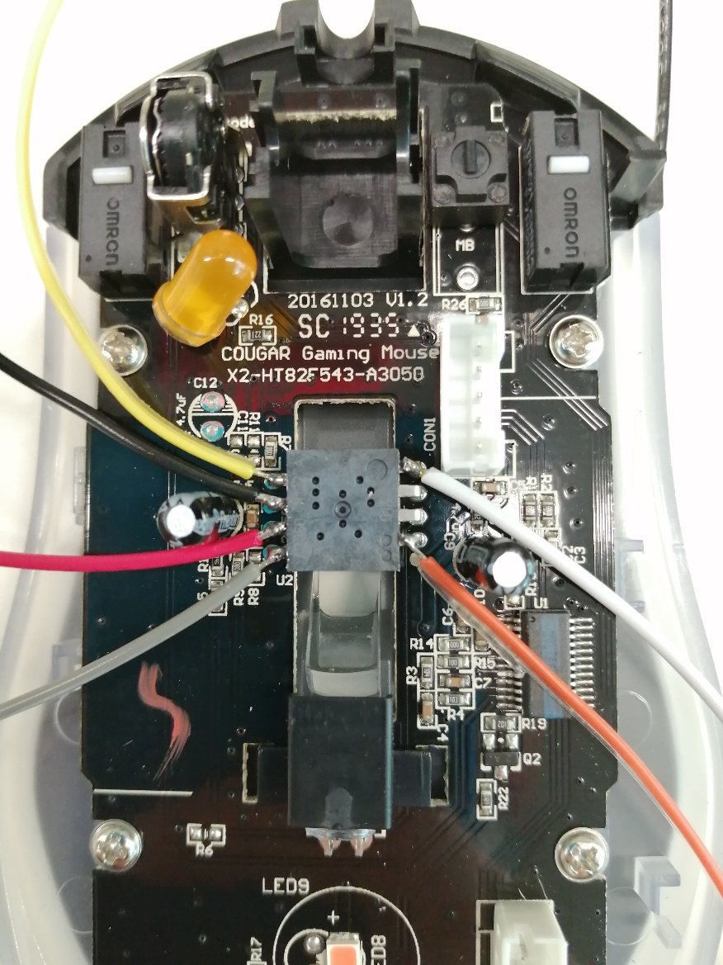
Figure 3: Soldered pins on the ADNS-2610.
All the 3D printable parts must be printed, the parts have been designed to be printed optimally with an Objet 30 (Polyjet resin printer), also have been printed with a Form 2 (SLA resin printer). The material used is the Vero gray resin and the Clear V4 resin with the Objet 30 and the Form 2 respectively. With both printers the settings have been the default settings.
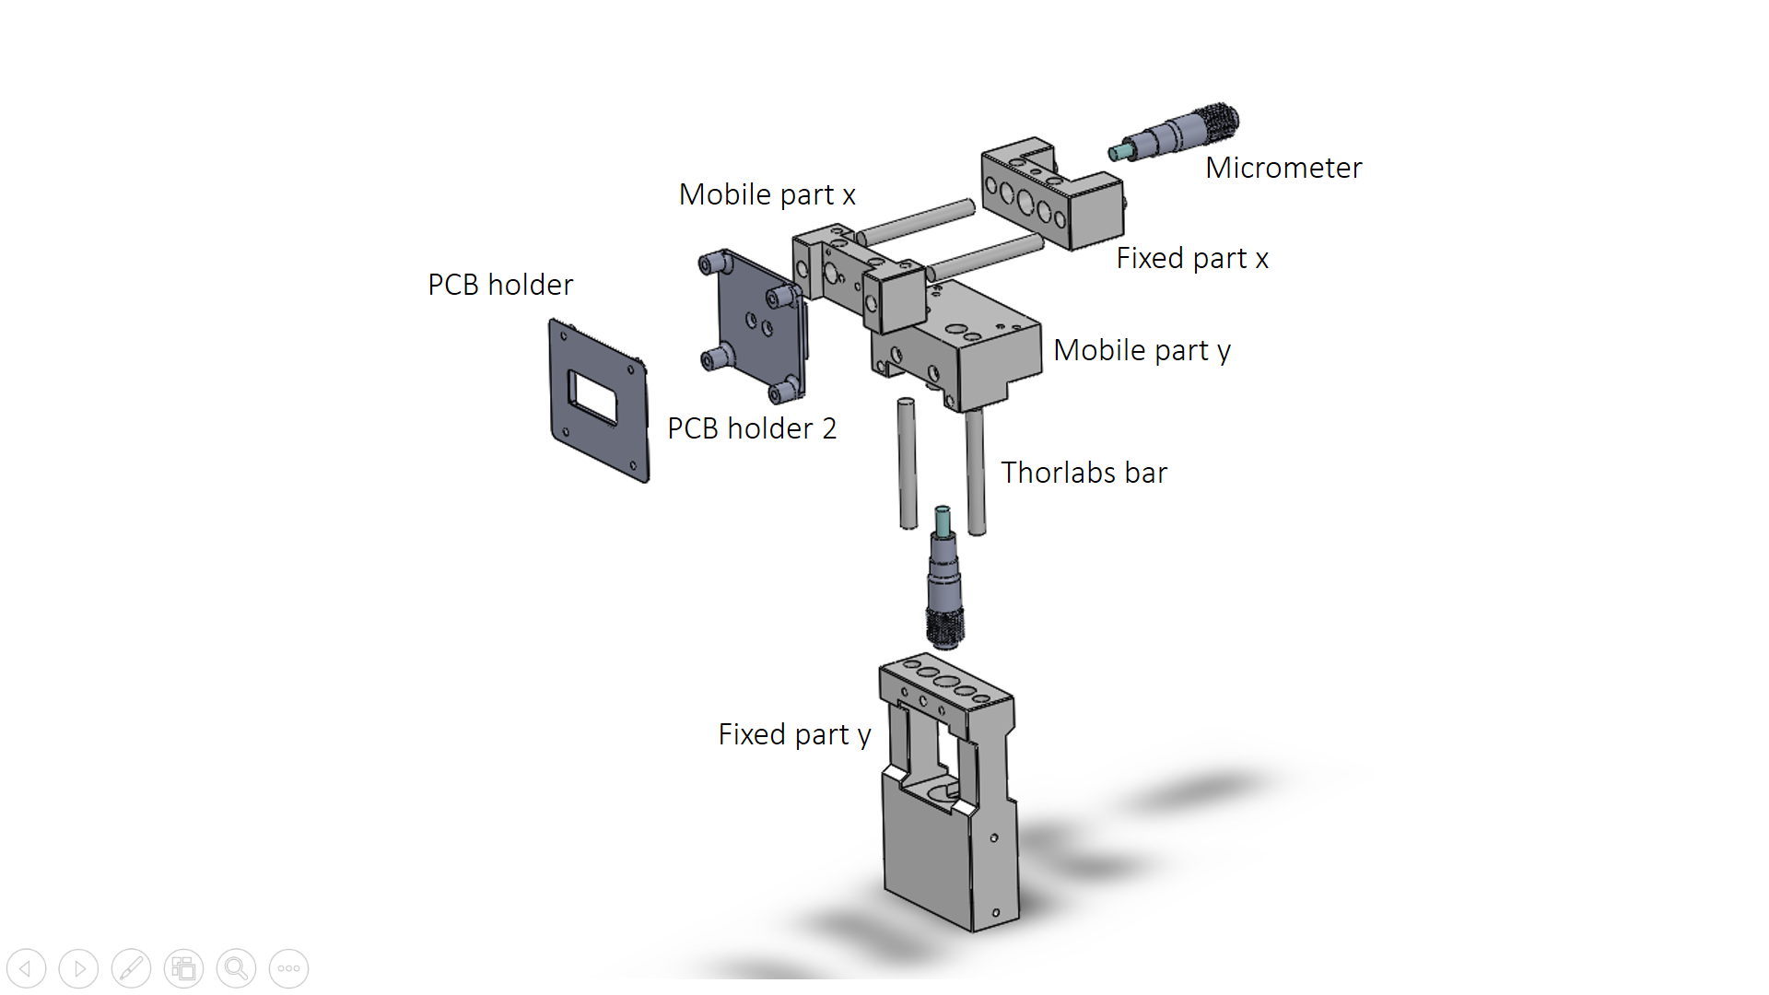
Figure 4: Main components of the assembly.
Once you have the 3D printed parts, put the M3 threaded inserts on the Mobile part x and Mobile part y. These threads have been created to block the system once the desired position is achieved.
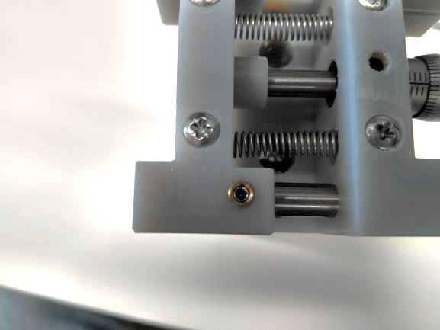
Figure 5: Threaded inserts on the 3D printed parts.
Insert the M6 threaded insert on the bottom of the Fixed part y.
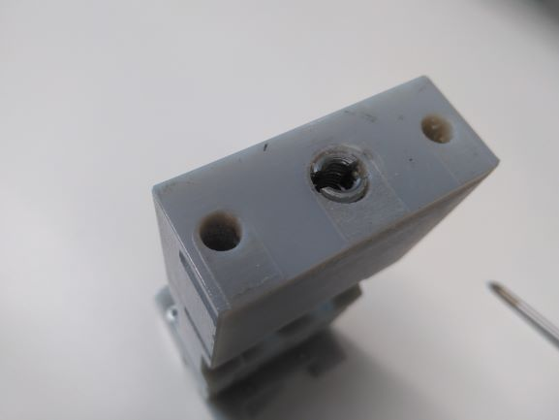
Figure 6: M6 threaded insert on the Fixed part y.
Insert the Thorlabs® bars on the Fixed part y and Fixed part x and use the Connectivity Male UNC 4-40 Screw to hold these bars.
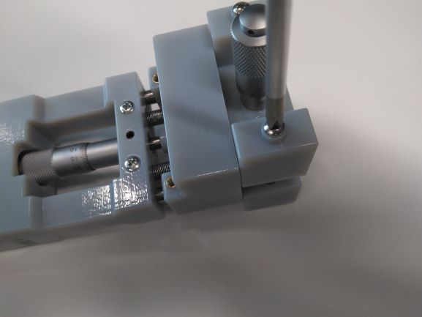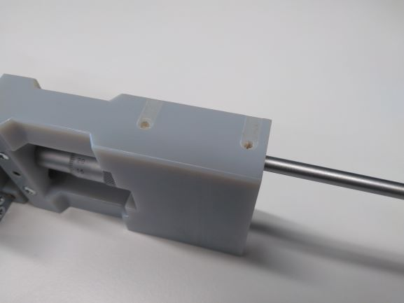
Figure 7: The connectivity male UNC 4-40 screwed with the Thorlabs bar thread.
Insert the two M4 Allen screw on the Fixed part x and y.
Insert the M3 x 20 mm screw and attach the extension springs on the Fixed part x and y. Use a tweezers to connect the two stages, the Fixed part and the mobile part for both stages inserting other M3 x 20 mm screws on the other stage.

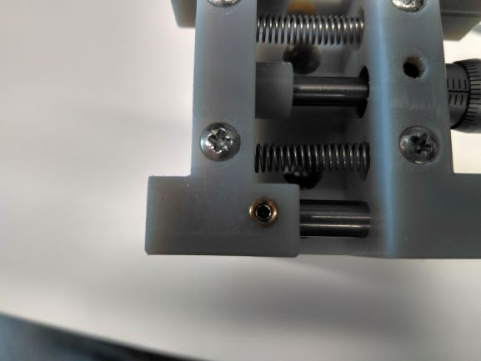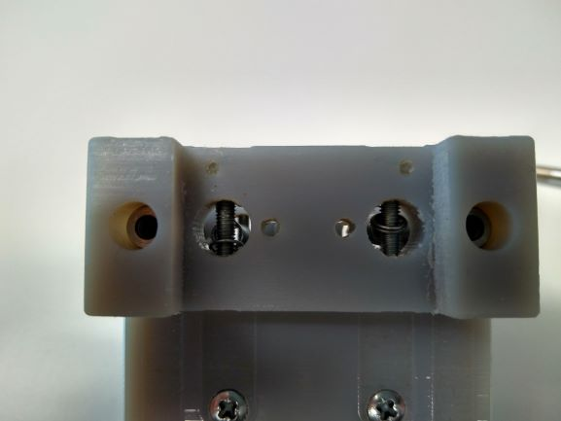
Figure 8: Extension springs attached between the mobile and the fixed part with the M3 20 mm screws.
Attach the micrometers using the M4 screw to make pressure with the circular hole.
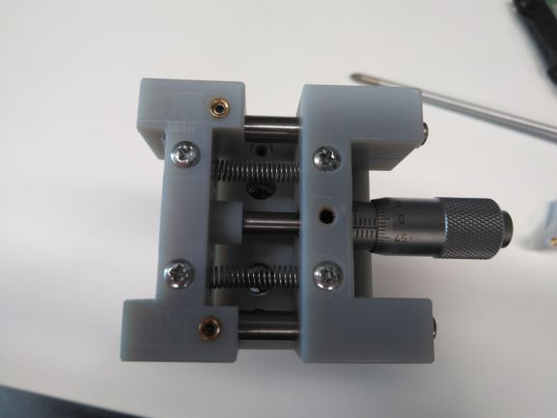
Figure 9: M4 screw holding the Micrometer.
Insert the four M3 x 20 mm screws to connect both stages (vertical and horizontal).
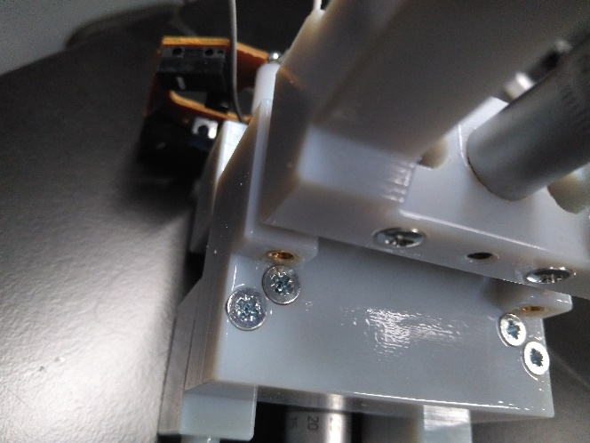
Figure 10: M3 x 20 mm screws to connect both stages.

Insert the two M3 screws attaching the sensor holder to the Mobile part x.
The lens and the PCB are assembled with the PCB holder part 1 and 2 placing the lens as in Figure 2 and inserting the screws to attach both parts together.
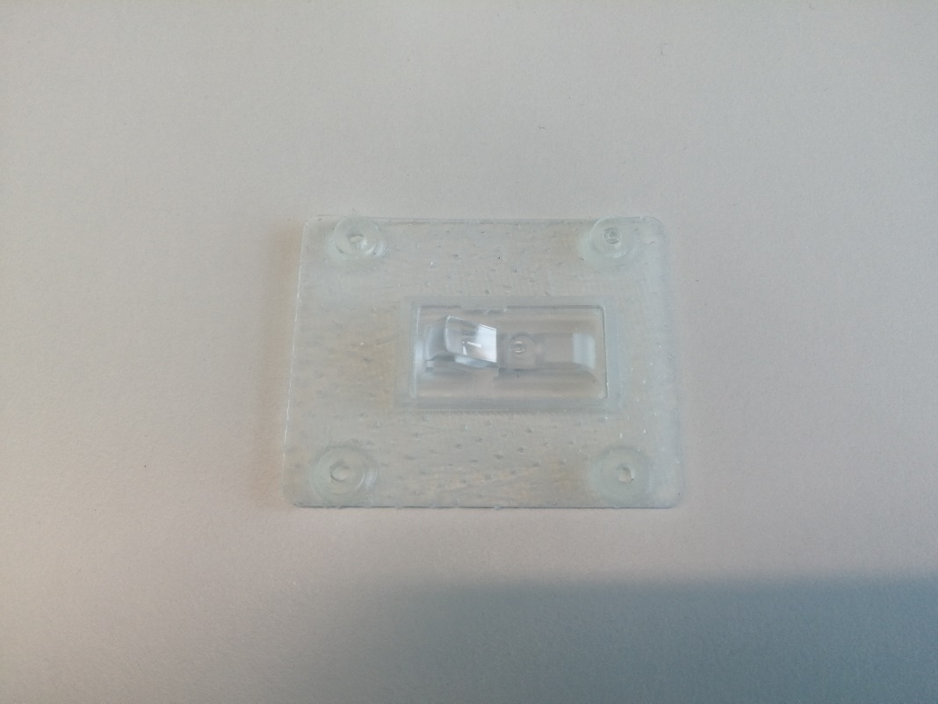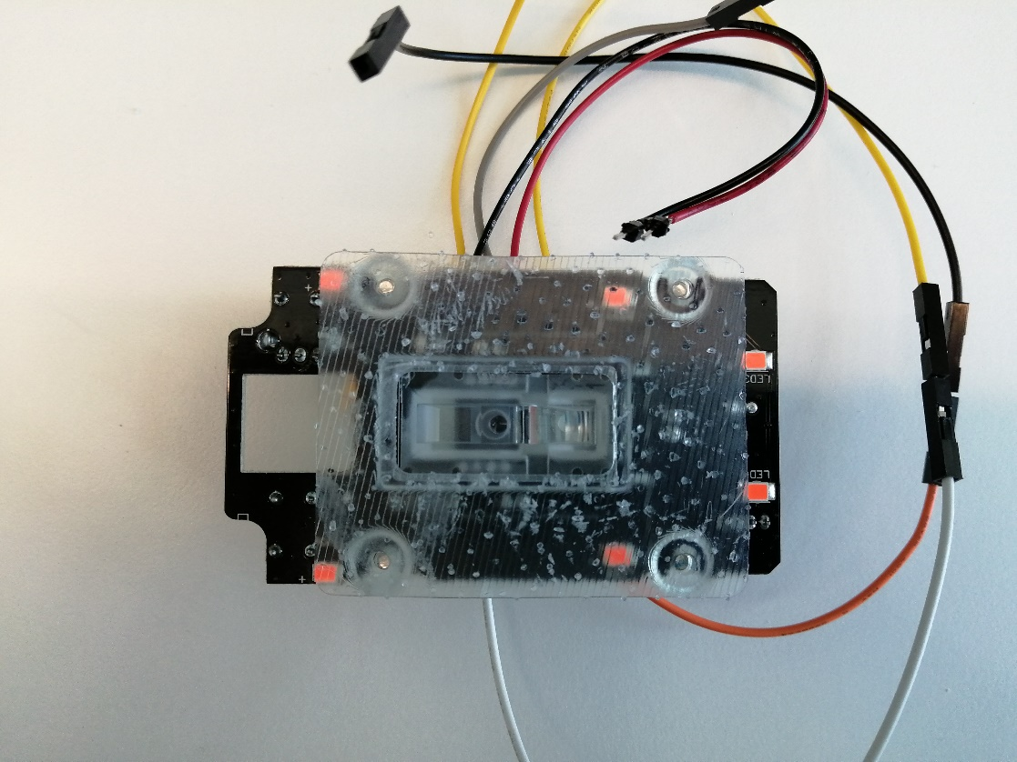
Figure 11: ADNS-3050 assembled with the lens.
Electrical connections described at the Control board file.
The provided library is the library created by Tom Wiggins on GitHub [3] for a 3D printable gaming optical mouse, project also published on Hackaday [4]. The library has been modified duplicating the functions needed to control and get data from two optical mice.
Calibration
The calibration can be done adjusting the vertical position (using the vertical micrometer) on the making coincident the equator of the sphere with the optical flow sensor.
Then the horizontal position can be achieved by adjusting the horizontal micrometer until a SQUAL value of 50 approximately.
Several recordings of 5 seconds at 1000 Hz have been made to get enough data to characterize the perimeter measured by the sensor and stablish the relationship between the actual perimeter and the previously mentioned. The recordings have been divided by rotating the sphere around the yaw and roll axes (Figures 12 and 13).
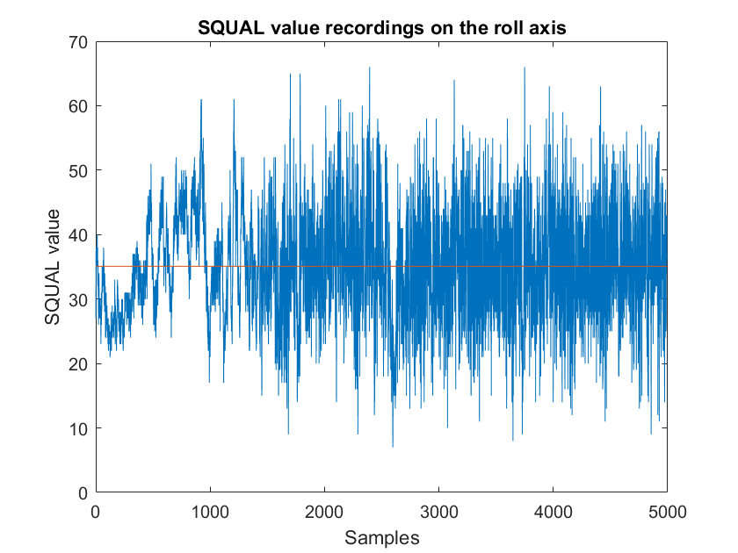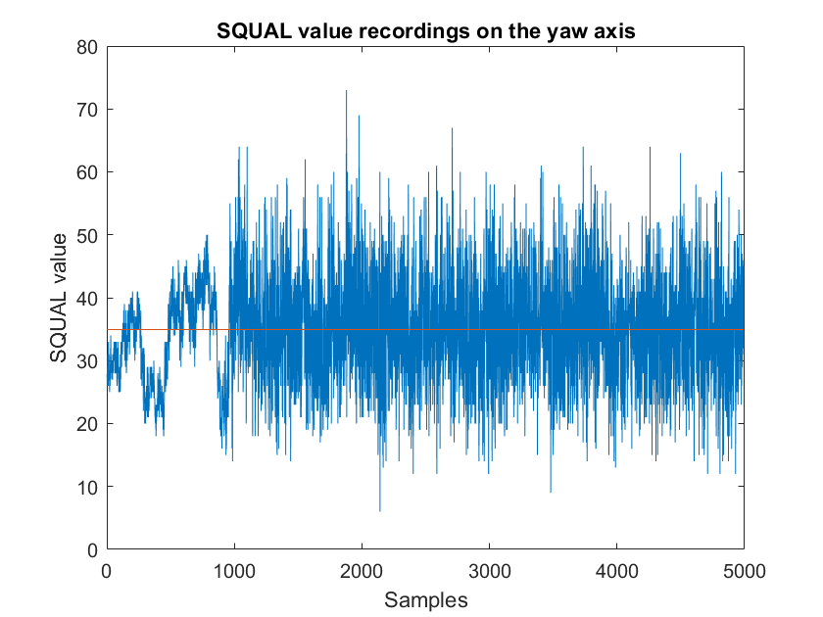
Figure 12: SQUAL value recordings for both axes.
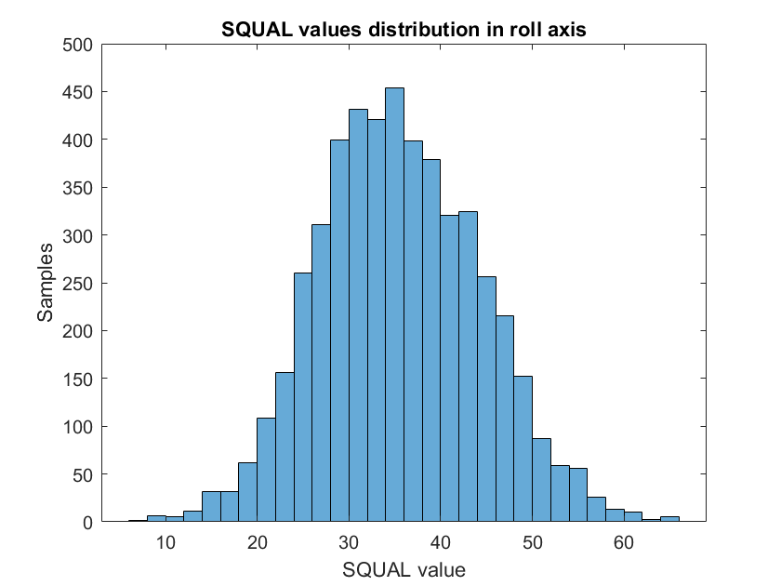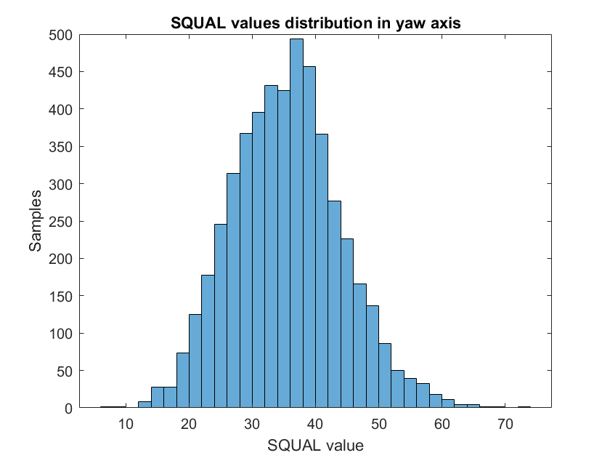
Figure 13: Distribution of the SQUAL value on each axis.
The results shown a homogeneous distribution of the SQUAL value depending on the relative distance change (Figure 14).

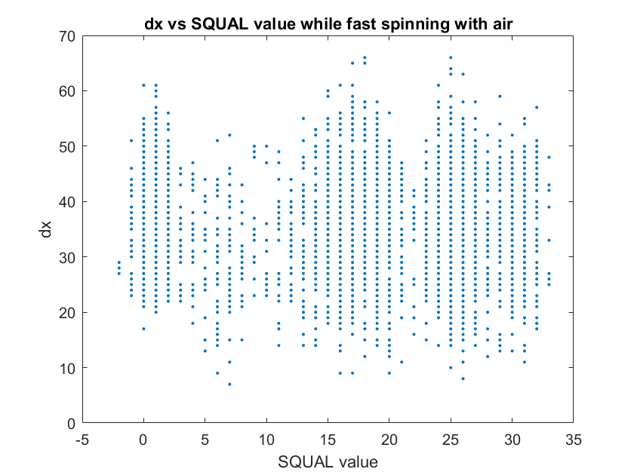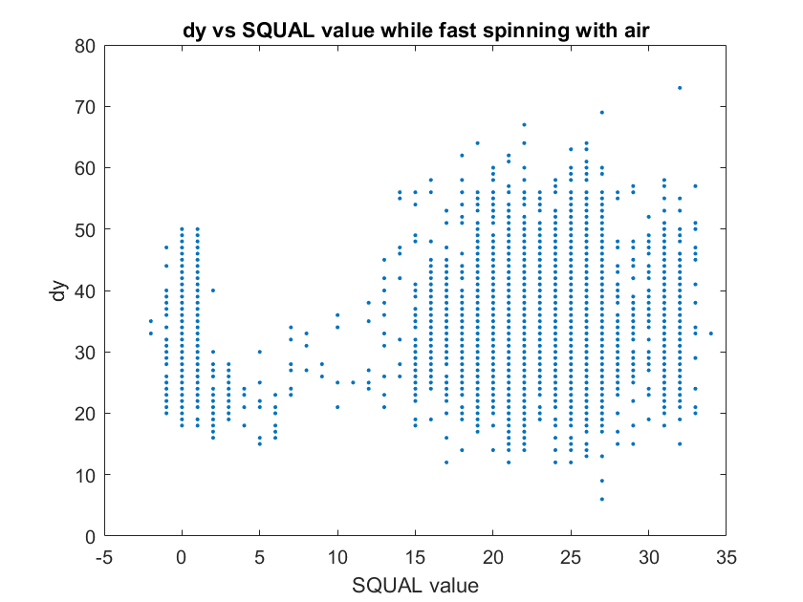
Figure 14: Relationship between relative displacements and the SQUAL value.
The most important results of this calibration process are the several measurements of one revolution for roll (N=6) and yaw axis (N=5). For each recording, the sphere has been rotated one revolution using an external mark. As can be observed in Figure 15, for both axes all the recordings converge in a final value. The final value used as a conversion factor to get SI units is the average of the absolute value of this samples (N=11). The average for the roll rotation axis is 21,966 and the average for the yaw axis is 20,109 mouse internal units and the average of these two values is 21,038 mouse internal units. The actual perimeter of the sphere is 61.89 cm and that gives us an equivalence of 339.92 mouse internal units per each cm.
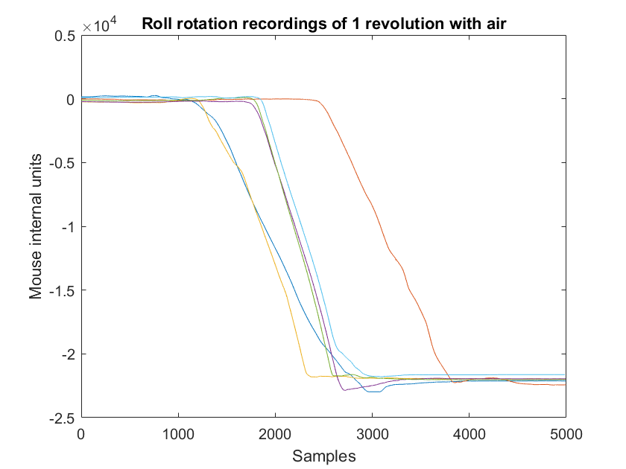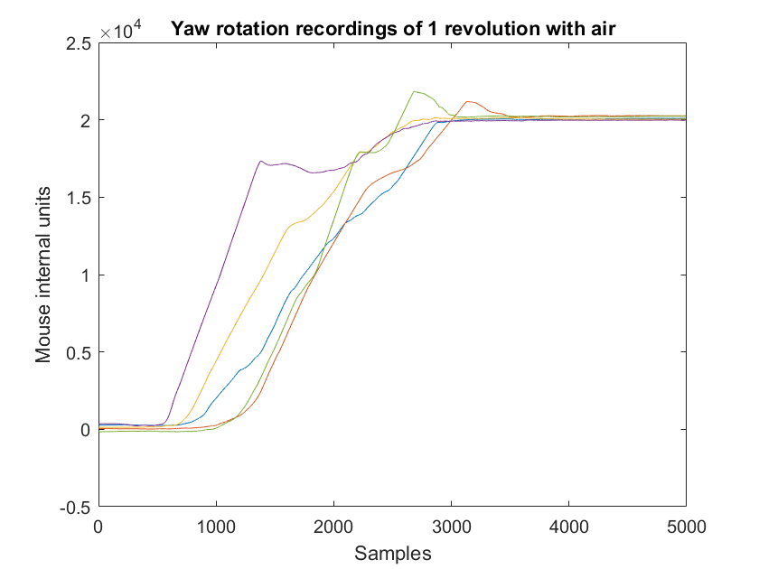
Figure 15: Recordings of absolute displacements in roll and yaw axes of one revolution.

References

[1] | "https://media.digikey.com/pdf/data%20sheets/avago%20pdfs/adns-3050.pdf," [Online].
[2] | "https://cougargaming.com/products/mice/minos_x2/," [Online].
[3] | "https://github.com/Tom101222/Adns-3050-Optical-Sensor," [Online].
[4] | "https://hackaday.io/project/18344-adns-3050-optical-sensor-mouse," [Online].

